CAN-GO 2
Intelligent control for Huawei telecom rectifiers with Home Assistant support
Touchscreen CAN controller for Huawei R48xx series rectifiers, especially for solar battery charging systems.
1. What is CAN-GO 2 for?
CAN-GO 2 is an intelligent touchscreen controller for Huawei telecom rectifiers. The output or charging voltage and the current limit can be adjusted on the display, while the device continuously measures and shows voltage, current, power and temperature.
Most common questions from solar users
- Can the charging voltage be adjusted: yes, directly on the CAN-GO 2 touchscreen.
- Can the charging current be viewed: yes, in real time, together with measured voltage and power.
- Does it work with Home Assistant: yes, the main measurements and status values are available over MQTT.
- Home Assistant role: monitoring and control over MQTT. Charging voltage, current limit and the Soft OFF switch can also be adjusted from the HA interface.
2. System overview
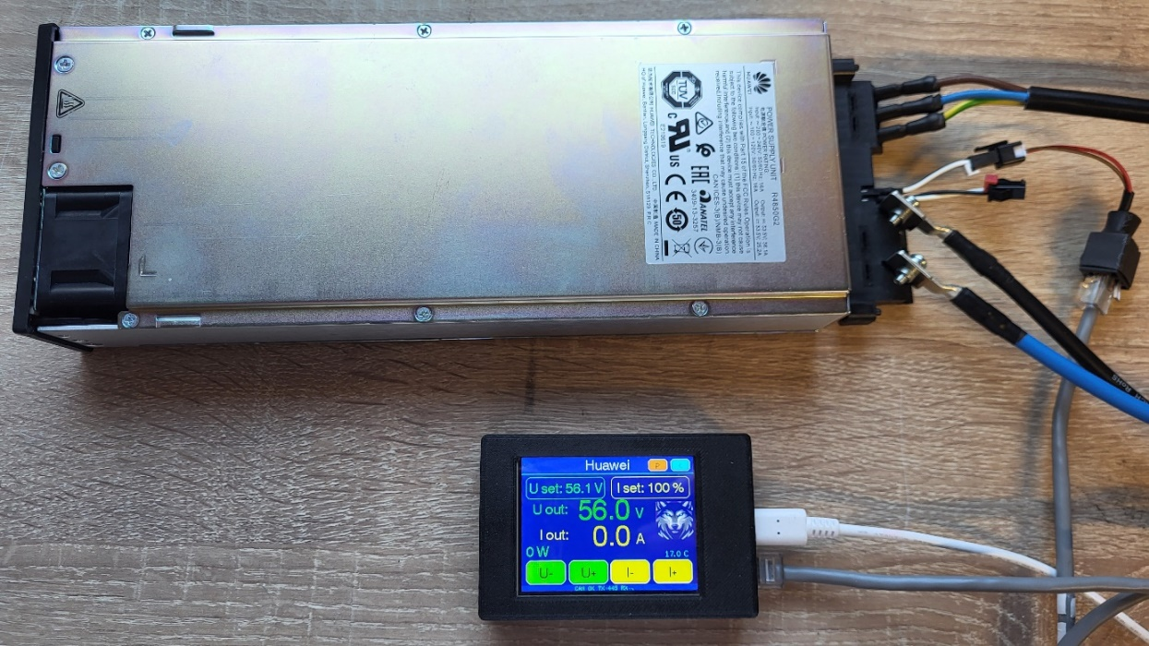
CAN-GO 2 with a Huawei rectifier. The display shows PSU settings and measured values.
3. Main screens
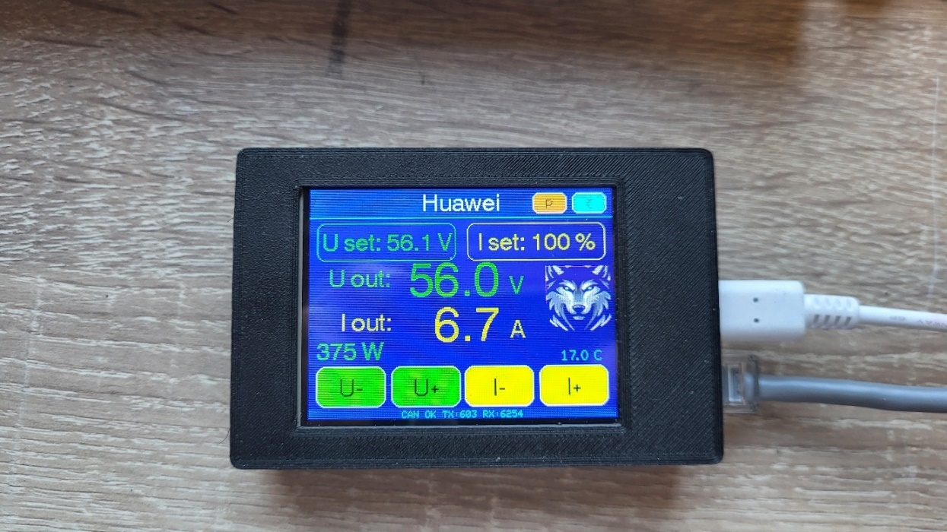
Huawei control screen. Voltage and current limit are adjusted here.
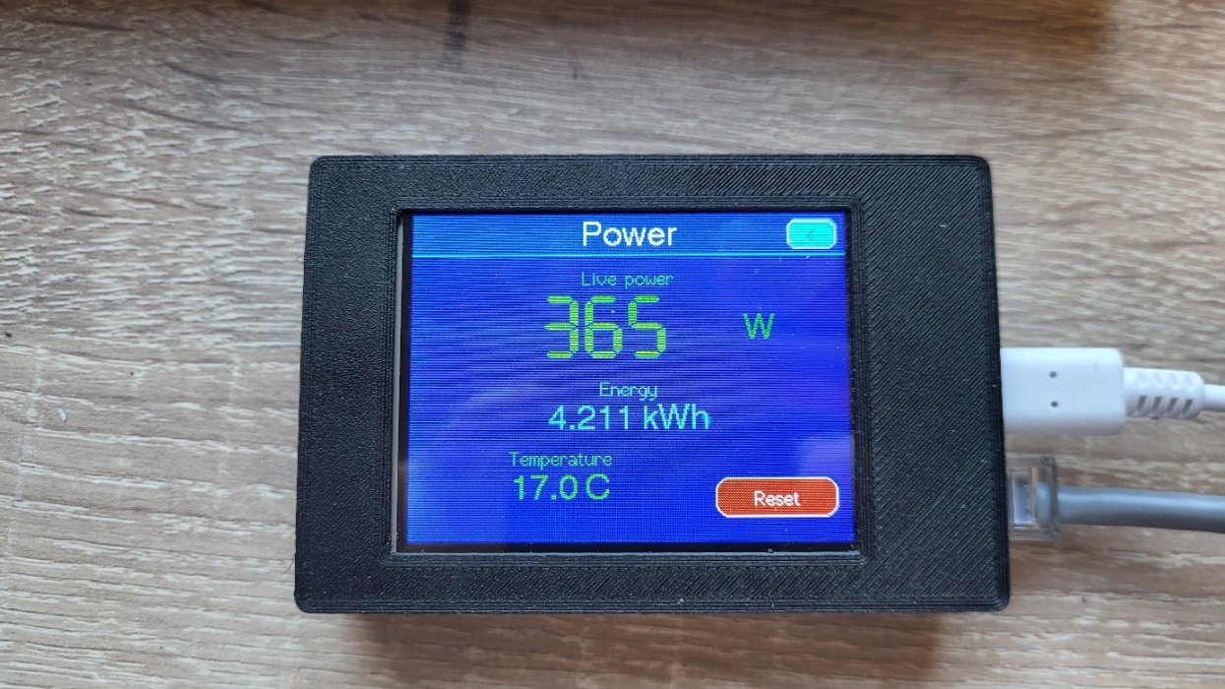
Power screen. Instant power, kWh and temperature are shown in large format.
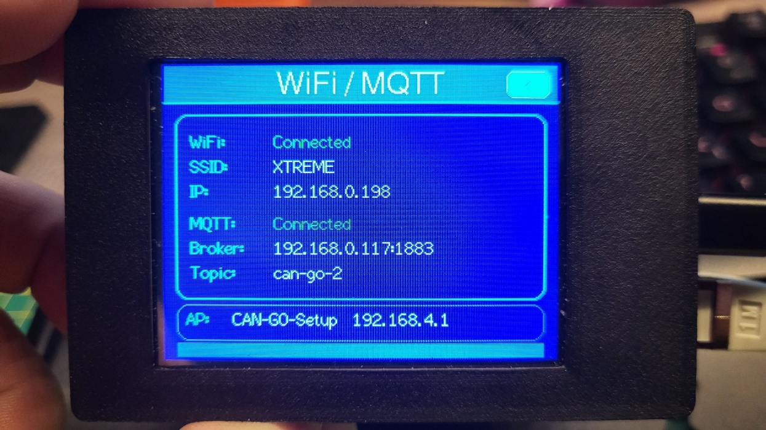
Wi-Fi / MQTT status screen. This shows network and MQTT connection status, plus the setup hotspot name and address.
4. Using the main control screen
- U set: configured output voltage
- I set: configured current limit
- U out: measured output voltage
- I out: measured output current
- W: instant power
- Temp: temperature
Touch buttons:
U- / U+: decrease / increase voltage
I- / I+: decrease / increase current limit
< top right: return to the main menu
P top right: power screen
5. Power screen
The P button opens a dedicated power page. It shows:
instant power in Watts
accumulated energy in kWh
temperature
The Reset button clears the kWh counter.
6. WiFi / MQTT setup
The WiFi / MQTT option is available from the main menu.
Open the Wi-Fi / MQTT menu.
The device starts its own hotspot: CAN-GO-Setup
Connect to this network from a phone.
Open this address in a browser: 192.168.4.1
Enter the local Wi-Fi and MQTT details.
Save the settings.
Note: the CAN-GO-Setup configuration network is currently available without a password. The local router Wi-Fi password is entered on the setup page opened from the phone.
MQTT fields for Home Assistant
MQTT host / IP: the local IP address of Home Assistant, for example 192.168.0.50.
MQTT port: 1883.
MQTT user: a Home Assistant username accepted by Mosquitto Broker.
MQTT password: the password for the user above.
MQTT topic: can-go-2.
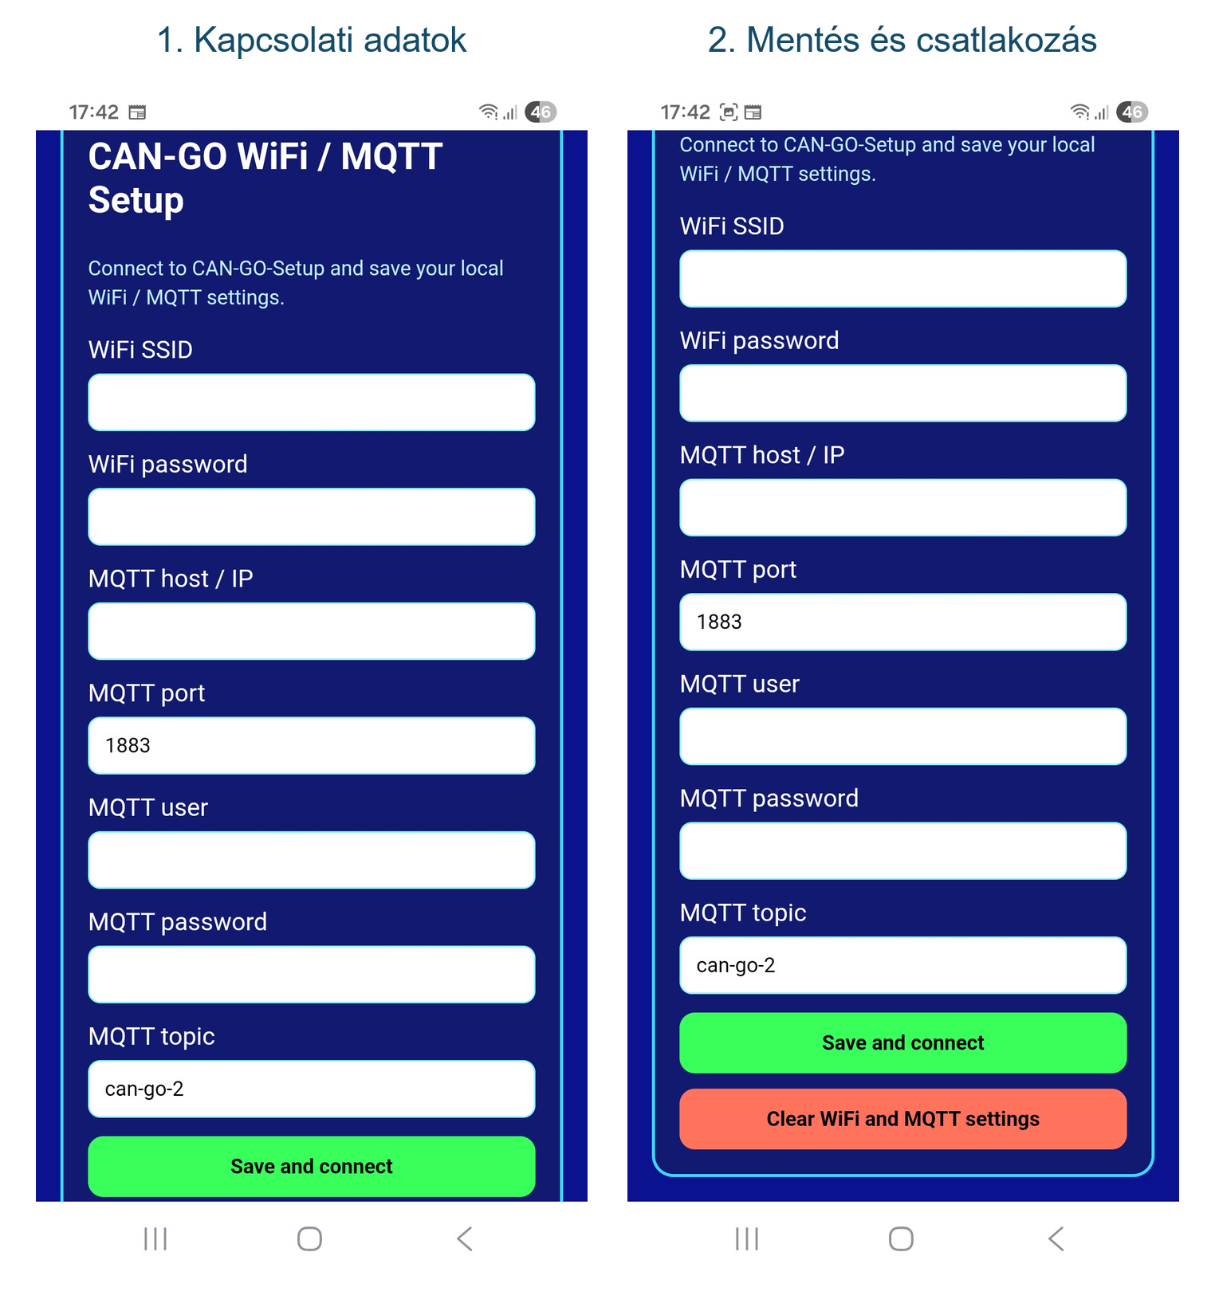
CAN-GO Wi-Fi / MQTT setup page on a phone. Save and connect stores the settings and starts the connection.
The Wi-Fi / MQTT screen shows:
Wi-Fi connection status
SSID
IP address
MQTT connection status
MQTT broker address
MQTT topic
7. Home Assistant usage
CAN-GO 2 sends measured values and status data to Home Assistant over MQTT. This makes charging visible and loggable from a phone or the HA dashboard.
Home Assistant support is no longer display-only: charging voltage, current limit and the Soft OFF switch can be controlled remotely over MQTT.
Required: a working local Wi-Fi network, an MQTT broker such as Mosquitto, and the Home Assistant MQTT integration.
Home Assistant can show PSU type, configured voltage and current limit, measured voltage and current, power, temperature, Wi-Fi IP address and CAN status.
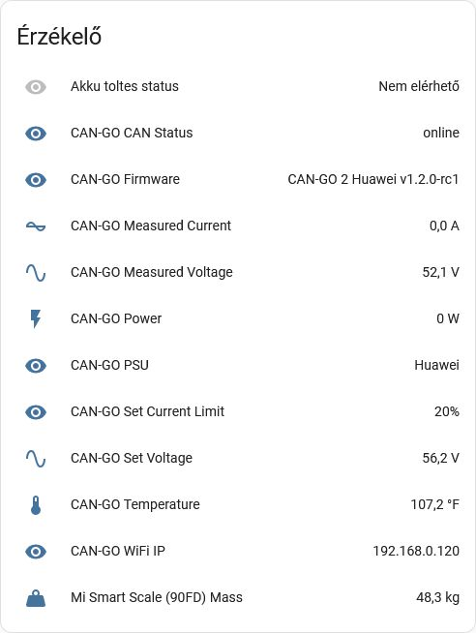
CAN-GO sensors in Home Assistant: measured voltage, current, power, temperature, configured setpoints, firmware status and CAN status.

Useful sales notes
First power-up
After power-up, the device shows the main menu. For Huawei use, select the Huawei button. The controller saves configured values, so after restart it continues with the previous settings.

Safety note
The rectifier can deliver high current. Wiring must only be modified with power disconnected. When charging batteries, always use a suitable fuse, correctly sized cables and supervision during the first test.

Current limit behavior
To maintain the current limit under load, the Huawei rectifier may reduce output voltage. This is normal behavior: the goal is to keep current close to the configured limit.

WiFi / MQTT setup
When entering the WiFi / MQTT menu, the device starts a setup network named CAN-GO-Setup. Connect to it from a phone and open 192.168.4.1 to enter local WiFi and MQTT broker details. Settings are saved after submission.

Quick troubleshooting
If CAN communication is missing, check CAN-H / CAN-L wiring, common GND and the 3.3 V supply of the transceiver. If the display works but the rectifier does not respond, first check CAN wiring and the selected PSU type.

Rectifier and connectors

CAN-GO 2 can be used with Huawei R48xx series rectifiers. The controller is powered through USB-C, while CAN communication goes to the rectifier through the RJ45 connector.

Huawei rectifier example
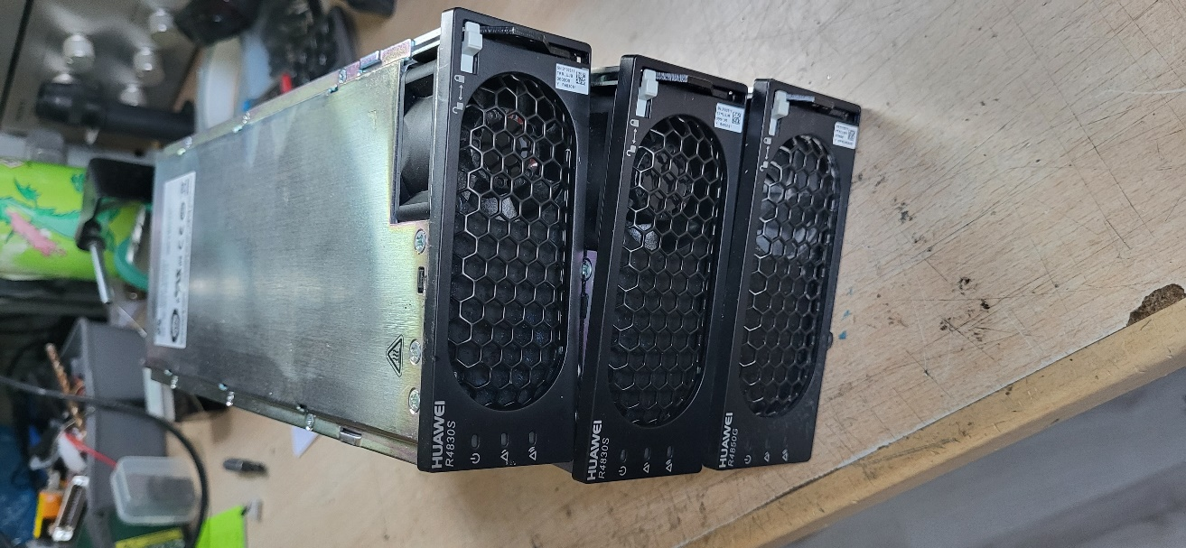
USB-C and RJ45 connectors on the CAN-GO 2 enclosure
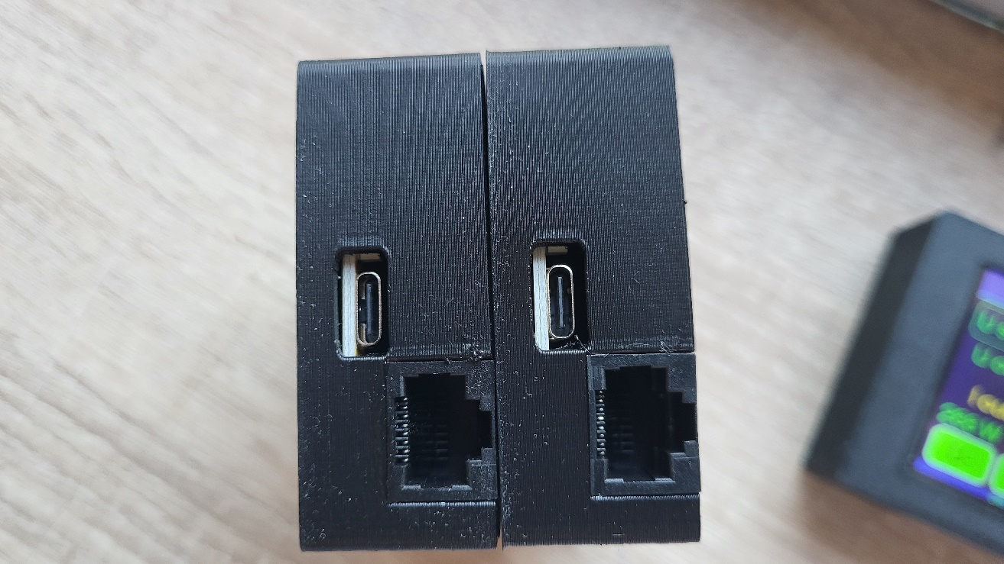
RJ45 CAN wiring
On the RJ45 socket, CAN bus is available on pins 4 and 5. Always verify connector numbering from the front view of the socket.

Pin 1 | Pin 2 | Pin 3 | Pin 4 | Pin 5 | Pin 6 | Pin 7 | Pin 8
- | - | - | CAN H | CAN L | - | - | -

Final wiring: CAN-GO RJ45 pin 4 = CAN-H, CAN-GO RJ45 pin 5 = CAN-L. On the rear connector of the Huawei R4850G2, pin 14 = CANH and pin 13 = CANL. The other RJ45 pins are not used.

RJ45 pinout diagram
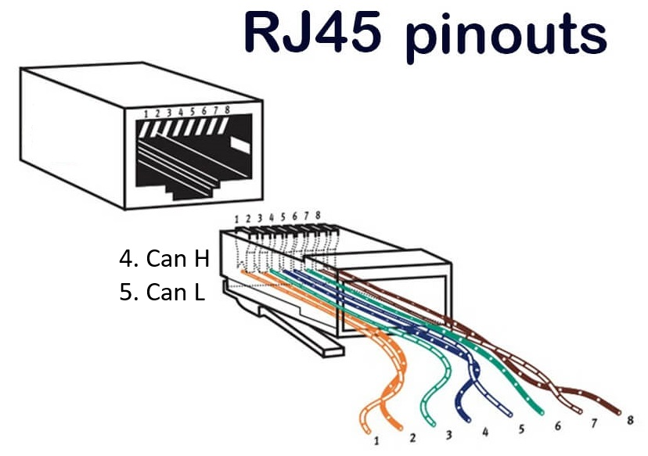
CAN-GO 2 RJ45 socket marking
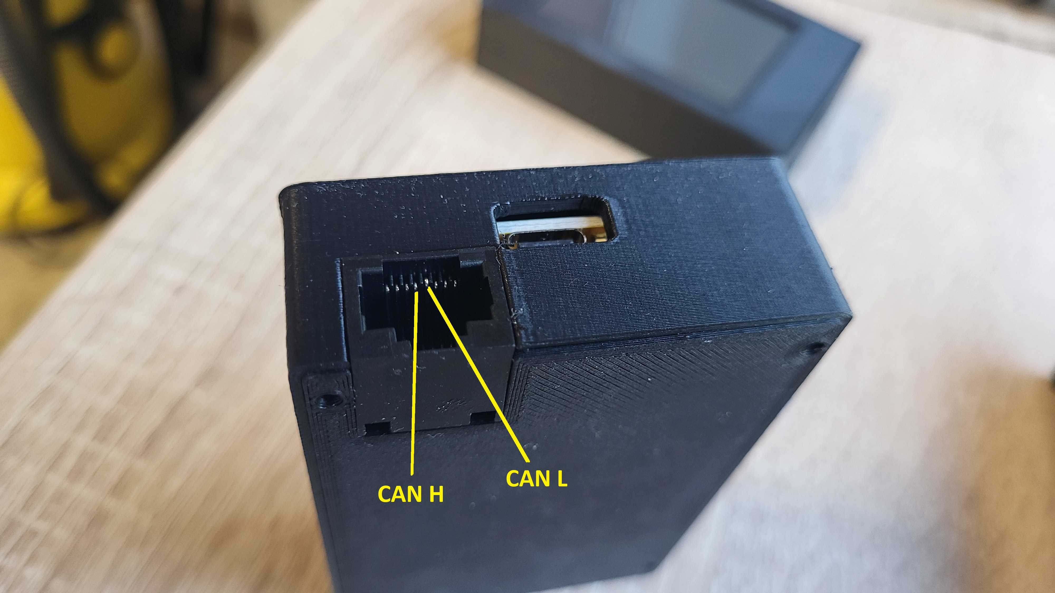
Huawei R4850G2 rear CAN points
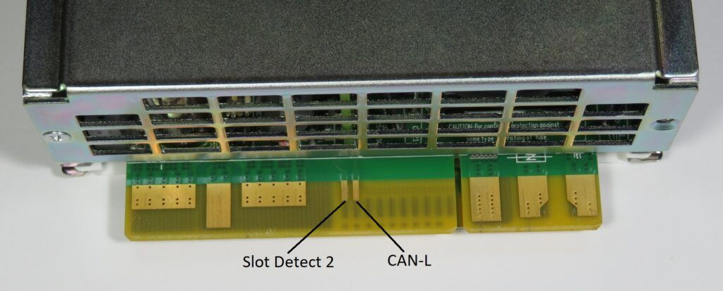
Huawei R4850G2 rear pin table
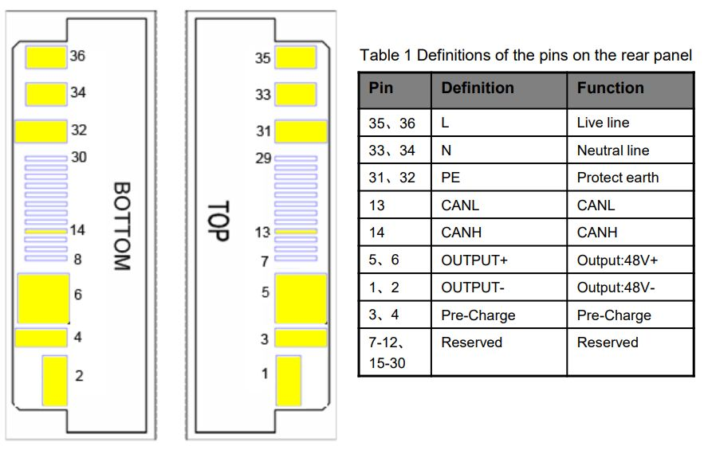

CAN-GO 2 Huawei v1.5.1 - Soft OFF function
In v1.5.1, the CAN-GO 2 Huawei firmware includes Soft OFF mode. This puts the rectifier into a 42 V standby state, allowing charging to be stopped without switching a high-power relay.
- Soft OFF disabled: normal charging with the configured U set and I set values.
- Soft OFF enabled: the controller sends 42.0 V and 20% current limit to the rectifier.
- Previous voltage and current limit settings are kept and restored after Soft OFF.
- In Home Assistant it appears as a separate MQTT switch: Soft OFF.
- Measured idle consumption is about 3-4 W, making it suitable as a standby mode for off-grid backup energy systems.

MQTT topics
Topic | Value | Function
<base_topic>/set/soft_off | ON / OFF | Soft OFF command from Home Assistant or MQTT
<base_topic>/state/soft_off | ON / OFF | Soft OFF state feedback
<base_topic>/state/charging | ON / OFF | Compatibility state for the older charging name
Note: when Soft OFF is ON, the output voltage target is 42.0 V. This is not mechanical isolation, but a controlled low-power standby state.

Home Assistant mobile view
In Home Assistant, CAN-GO 2 v1.5.1 shows and controls charging voltage, current limit and a dedicated Soft OFF switch. The switch puts the rectifier into 42 V standby while live voltage, current and power data remain visible.
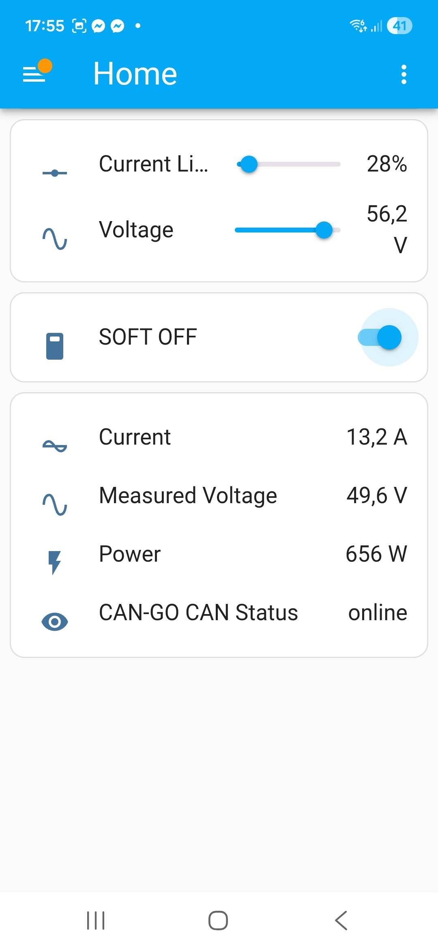 | 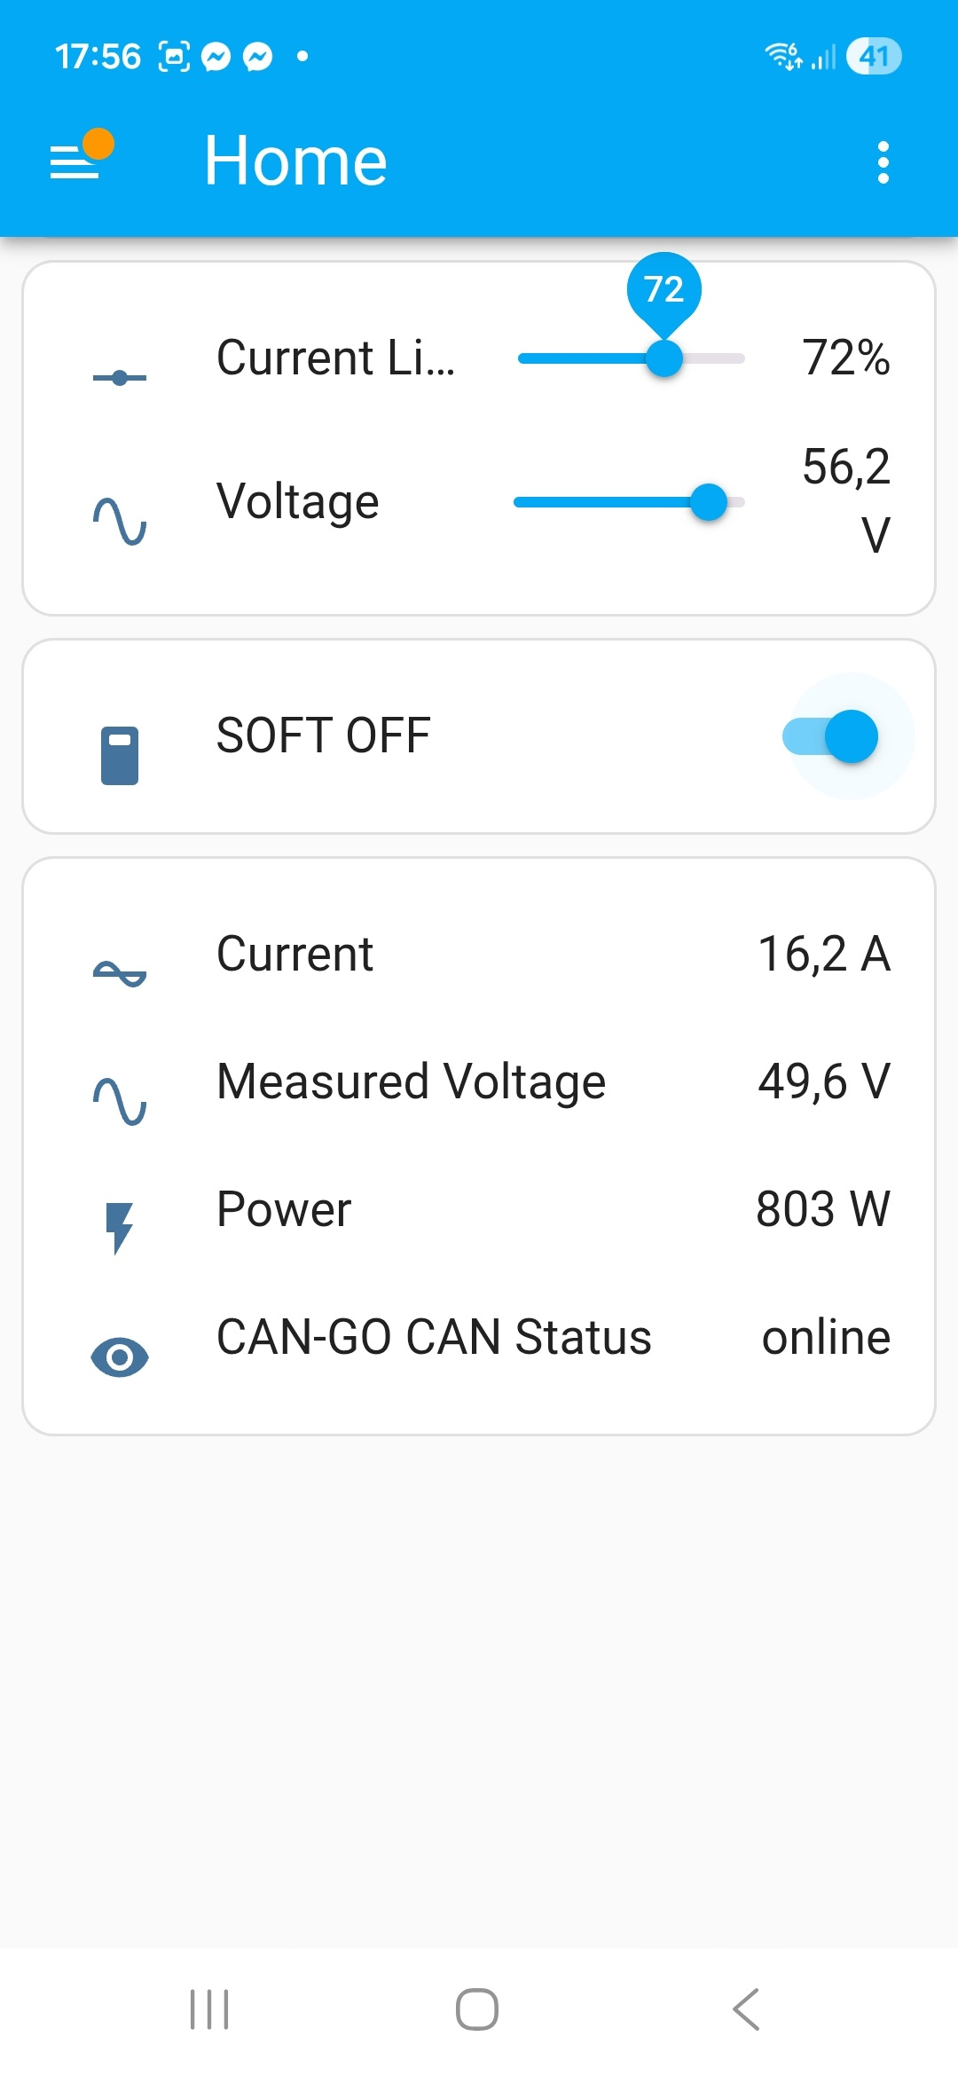 | 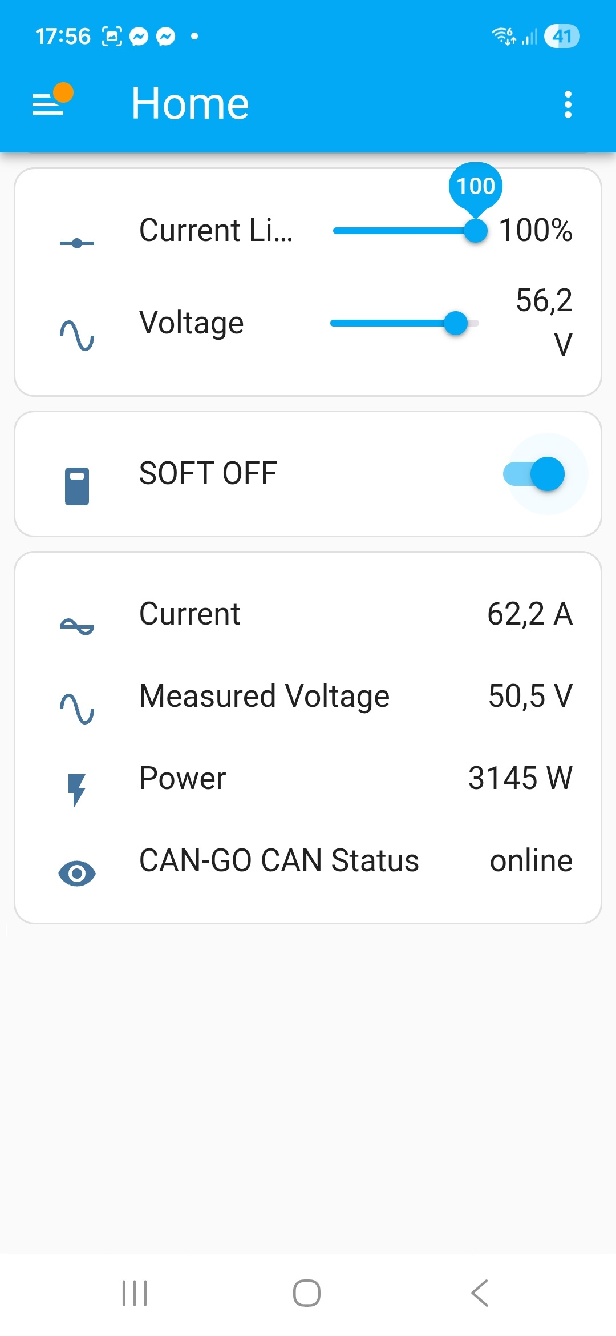
Current limit 28%, Soft OFF switch and live measured values | Current limit 72% during phone-based HA control | Current limit 100%, showing about 3 kW power
The screenshots show that configured current limit, voltage, the Soft OFF switch, measured current, measured voltage, power and CAN status can all be viewed from a phone.

CAN-GO 2 v1.5.1 - Soft OFF and display sleep
The new screens show Soft OFF operation, WiFi / MQTT status, the display sleep shortcut, the Power screen and switches available from Home Assistant.
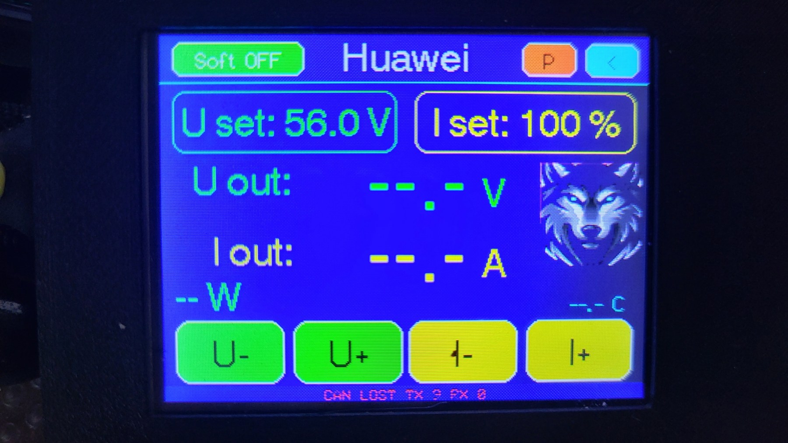 | 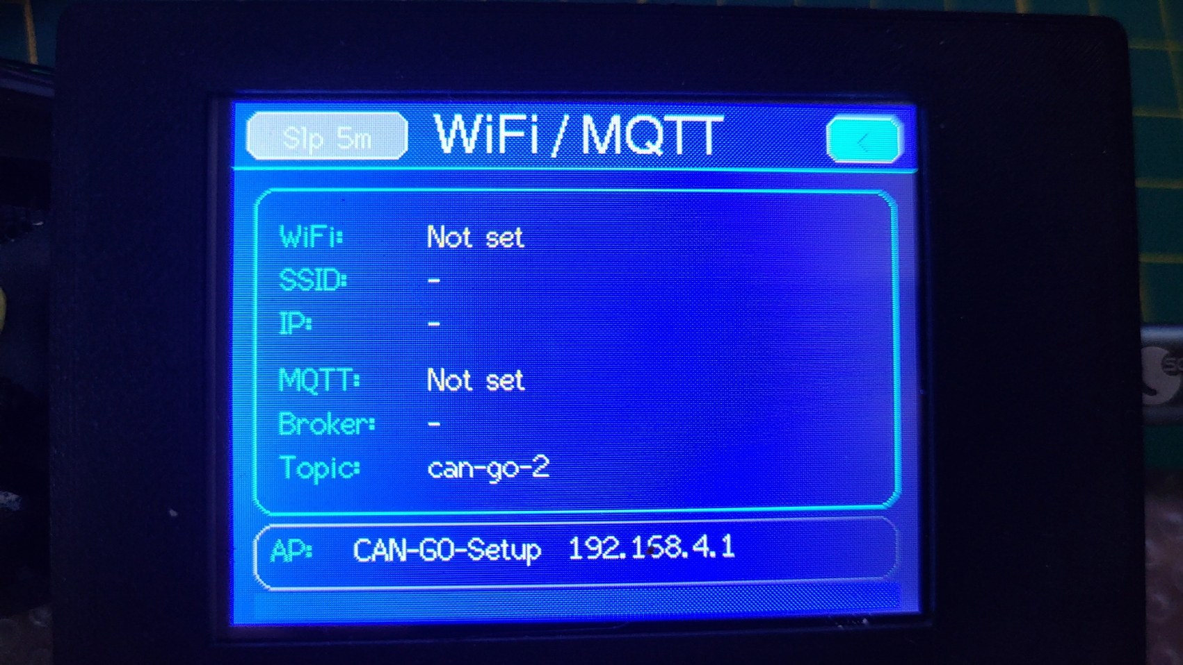
Soft OFF display: the rectifier can be switched to 42 V standby while keeping previous settings. | WiFi / MQTT status and display sleep shortcut, for example with a 5-minute dimming time.
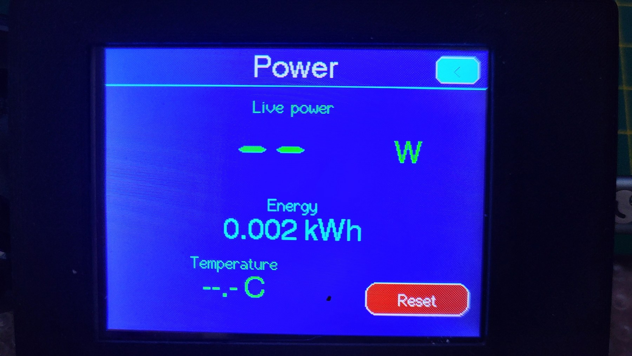 | 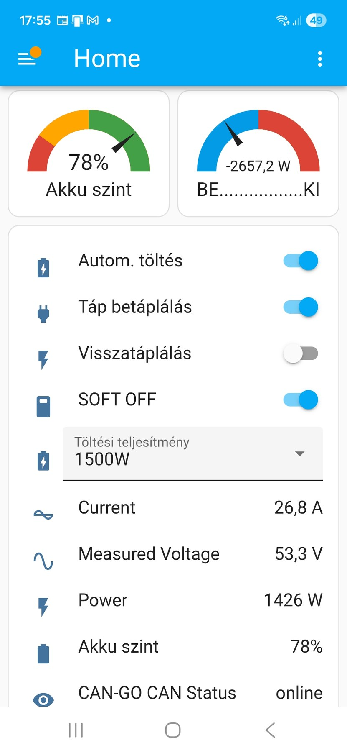
Power screen: live power, energy, temperature and reset function. | Home Assistant view: Soft OFF switch, charging power, live measurements and CAN status.

